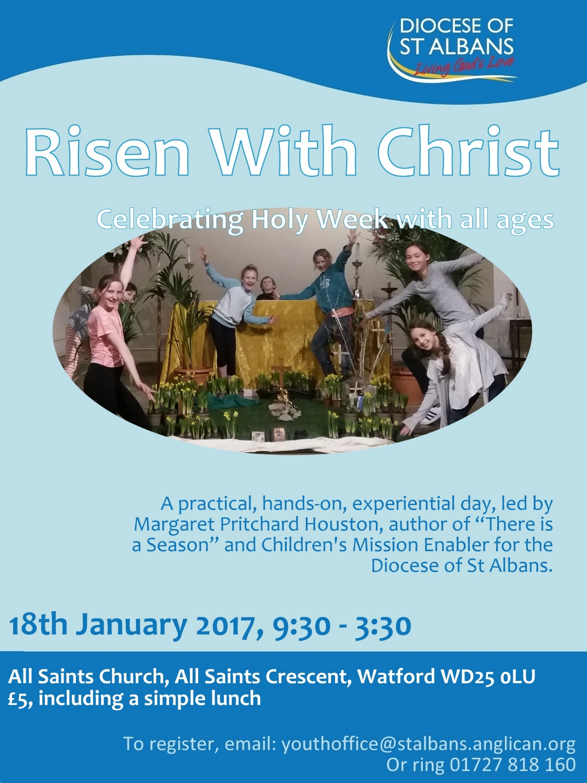

cme@stalbans.anglican.org
01727 818 176
@stalbanscme
Stalbanscme.com

Overview of the Passion – suitable for Messy Churches, after-school clubs, etc., where children may not attend church services during Holy Week.

You will need:
1 volunteer to play Jesus
A robe
6 tea lights
Branches of some sort
Pitta bread and grape juice
A wine glass and a plate (or you can use a chalice and paten)
A bowl of warm water, a jug, and a towel
A pillar candle and matches
Flowers

Space/furnishings:
A place for everyone to gather by a door
A place for everyone to gather by a table
A place for everyone to gather in the dark
A place for everyone to celebrate (ideally, an outdoor garden)

I’ve never officially used a script – this one is based on what I say, which itself is based on Gretchen Wolff Pritchard’s retelling in her “Palm Saturday” programme at St. Paul’s Church (later St. Paul and St. James’s) in New Haven, Connecticut, USA, which she summarised in her book, Risen With Christ (available from the-sunday-paper.com and Amazon).

I’ve successfully used this with a mixed group of children where the youngest was 3 and the oldest was 14, but if most of your group is under 7, you’ll probably want to adapt it.

PALM SUNDAY

Gather the children by a door, and hand out palm branches. The volunteer playing Jesus should be on the other side of the door.

I want you to imagine it’s two thousand years ago. We’re Jews, and we’ve gathered in the Holy City of Jerusalem to celebrate the Passover, the time when we remember how God set us free from being slaves in Egypt.

But we’re not free. The Romans are in charge of our land.

They can tell us where to go, and what to do.

They tax us relentlessly, then spend our money on their palaces and chariots.

They try to make us worship their false gods instead of the real God.

We want FREEDOM! And we want it NOW!!

What do we want? (Get the children to yell FREEDOM!) When do we want it? (get the children to yell NOW! Keep this up for a while – whip them up a bit.)

But you know what? I’ve heard that man, Jesus, from Nazareth, is coming into Jerusalem. The one who’s been healing and preaching all around the country? And I hear he might actually be the MESSIAH, God’s chosen one, who’s going to set us free. He’ll raise an army and kick out the Romans! And I’ve heard he might actually be here, now!

So when he comes, we’re going to greet him properly. We’re going to wave these palm branches in the air like we would for a King, and we’ll shout “HOSANNA,” which means “praise be to God who will save us.” Can we practice that?

(When they’ve had a go, continue …)

I think Jesus might be coming near. ______, can you go check to see if he’s here yet?

(Send a child to the other side of the door to where your volunteer ‘Jesus’ is waiting. When he finds him, get the children shouting HOSANNA and waving their palms. Follow Jesus as he leads you to the table surrounded by chairs, shouting Hosanna and waving palms. Get children seated in the chairs around the table. Jesus stands behind the table, which is set with 6 lit tealights, a glass of grape juice or Ribena, and a plate of pitta bread. Somewhere nearby, you have a bowl of warm water with a jug and a towel. Get the children settled and either collect their palm branches or have them place them under or behind their chairs, so they can’t mess with them.)

Now we’re Jesus’s special friends, his disciples. He’s been in Jerusalem for four days, and today we’ve gathered in an upper room to celebrate the Passover festival. We’ve come in secret, in groups of two or three, because the leaders of the people are scared that Jesus will take away their power, so they’ve been looking for him, to arrest him.

As everyone sat down to dinner, Jesus said, “truly, I tell you, one of those sitting here will betray me to my enemies.” And everyone started arguing – “is it me?” “I bet it’s him – I never trusted that guy …” “maybe it’s James …” “maybe it’s you?” And one of Jesus’s friends, Judas, said, “is it me, Lord?” and Jesus said, “do quickly what you have to do.” And Judas got up and left.

Jesus’s friend Peter started bragging, saying, “Lord, I will NEVER betray you, I’m SO faithful – if I have to DIE with you, I will, but I’ll NEVER hurt you.”

And Jesus said, “Peter, I say to you that before the rooster crows at sunrise tomorrow, you will deny three times that you even know me.”

(Have a child blow out the first candle.)

As they were starting to eat, Jesus lifted up the bread, and blessed it. (Jesus lifts up the pitta bread)

But instead of using the regular words of blessing, he said something different. He broke the bread (Jesus does so) and he said, “this bread is my body, which is broken for you. Every time you eat it, do this to remember me.” And he gave them some to eat. (Jesus offers each child a bit of bread.)

The disciples were confused, and scared – they thought Jesus was the Messiah, a great King who would kick the Romans out and bring in the Kingdom of God, and here he was saying that the bread was his body, and it sounded like something awful was going to happen to him, like maybe he was even going to die.

And then Jesus lifted up the wine, and again, instead of saying the normal blessing, he said, “this wine is my blood, poured out to save people everywhere from their sins. Every time you drink it, do this to remember me.”

(Jesus lifts up the “wine” and offers the cup to each child. Have a child blow out the second candle.)

Now the disciples were really getting worried. What was happening? Wasn’t Jesus going to fight the Romans and bring in the Kingdom? They started doing what people often do when they’re confused and scared – they started arguing.

They argued about who was going to be most important in Jesus’s Kingdom. “When Jesus is King, I’m going to be the Prime Minister,” “you can’t be Prime Minister – you’ve only been following him a little while, I’ve been with him from the beginning. You can be Secretary of the Treasury.” “No you can’t, you can’t even add up – how could you be Secretary of the Treasury.”
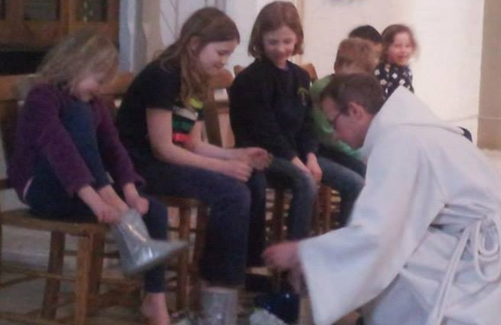
When Jesus heard them fighting, he didn’t say anything. He simply took a bowl, and a towel, and a jug of water, and he got down on their knees, and he washed their feet.

(Jesus takes out the jug, bowl, and towel. Instruct the children that if they want to have their feet washed, they take off their shoes and socks. Remind them that the water is warm. While the feet are being washed, ask: )

Who washes you? (parents, caregivers, grandparents, nannies, etc.)

What about when you’re very young or very old? Who washes you? (nurses, family members)

Does the Queen wash you? When you’re in hospital, is it the most important doctor who comes to your room to wash you?

No, it’s not the people with lots of power and money who wash others. It’s people like mums and dads and grandparents, nurses …

Jesus said to his disciples, “You don’t get it. Being important in my Kingdom isn’t about having the most power or the most money. In my Kingdom, the one who is the most important is the one who serves other people.”

And then they went out to the garden, to pray.

(Pause if needed for shoes and socks to go back on. Jesus moves away from the group around the table and turns his back.)

In the garden, Jesus said to his friends, “stay here and wait with me one hour, while I pray.” And he went away and he prayed, “Abba, Father, please don’t make me do this. If it’s possible, let there be another way. Take this cup from my lips. But if there’s no other way, then I will do it.”

He went back and found all his friends asleep, and he woke them up, saying, “can you not stay awake one hour?” Then he went away to pray a second time – “Abba, Father, take this cup from me, but if there is no other way, then your will be done.” And again, he came back and found them sleeping. A third time he went away to pray – “Abba, Father, please don’t make me do this - but if there is no other way, then your will be done …” and this time as he went back to his friends, they heard the sound of soldiers marching, and there were lights and voices shouting, and suddenly the garden was full of Roman soldiers and the Jewish Temple police, and Judas was there, and he went up to Jesus, and said, “master,” and he kissed him. And this is how the police knew which one was Jesus. So they grabbed him, and put his arms behind his back, and arrested him.

And all his friends ran away.

(A child blows out the third candle.)

They took Jesus first to the religious leaders, who told lies about him and hit him in the face, and agreed that he had committed crimes against God and deserved to die.

Peter, one of Jesus’s friends, had snuck back to watch what happened, and he waited outside the Chief Priest’s house, around a fire. And one of the Chief Priest’s servants said, “hey, weren’t you with Jesus in the garden?”

And Peter said, “no, not me, I wasn’t there – never met him, you’ve got the wrong guy.”

But the servant said, “I definitely saw you there. You’re one of this troublemaker’s friends, aren’t you?” And Peter said, “not me! I don’t want any trouble!”

Another servant said, “you talk like him. You’ve got the same accent. You’re sure you aren’t one of his friends?” And Peter shouted, “GOD DAMMIT, I TELL YOU I DON’T KNOW HIM.”

And just then, the rooster crowed. And Jesus was brought out by the religious leaders, and when Peter saw him, he remembered how he’d bragged about being so brave, and how Jesus said, ‘before the rooster crows, you will deny three times that you even know me.’

And he went away, and wept.

(A child blows out the fourth candle.)

Now, only the Roman governor could sign the papers for a criminal to be put to death, and for that, they needed a crime against Rome.

So the religious leaders brought Jesus to Pontius Pilate, the Roman governor.

“This man tried to lead an attack on Rome,” they said. “He claims to be the King of the Jews. He wants to fight against Rome. He’s a terrorist.”

So Pilate asked Jesus, “are you the King of the Jews?” And Jesus said, “why do you ask me that?”

Pilate said, “these other people tell me you say you’re a King. Are you?” And Jesus said, “my Kingdom is not of this world.”

And Pilate thought, “this man is harmless. Maybe he’s crazy, but he’s not a threat.” At the Passover, it was traditional for the Roman governor to free a Jewish prisoner to honour the festival of their freedom. Outside Pilate’s windows, a crowd was gathering to demand the release of a man called Barabbas, who was a terrorist who had killed Roman soldiers.

(Get the kids shouting “Barabbas! Barabbas! We want Barabbas! Give us Barabbas!” etc.)

But Pilate wanted to release Jesus instead. So he told the crowd, “I know you want your prisoner – and you’ll get him. But overnight a new prisoner has been brought into me – Jesus of Nazareth. Should I release him or Barabbas?”

And some of the crowd thought, “yeah, let’s have Jesus – I know him, he’s a teacher and a healer, how could he be a bad guy? Barabbas is violent – let’s have Jesus instead.” So they started shouting for Jesus. (get half the kids shouting “Jesus! Give us Jesus!” and then stop them.)

But the others thought, “what’s Jesus ever done for us? Barabbas fought for Israel! He’ll kick out the Romans! Jesus won’t even pick up a sword!” So they started shouting for Barabbas. (get the two halves shouting “JESUS!” “BARABBAS!” at each other.)

And Pilate began to be afraid that there would be a fight, and the Emperor would hear about it, and he’d lose his job. And the crowd shouting for Barabbas was getting louder and louder.

(gradually silence the children shouting for Jesus, until Barabbas prevails.)

So Pilate said, “what do you want me to do with Jesus?”

And the crowd shouted, “CRUCIFY HIM.” (Get the children to shout it with you.)

Pilate said, “why? What evil has he done?”

But they only shouted louder, “CRUCIFY HIM!” (Get the children to shout it with you.)

So Pilate realised that unless he released Barabbas, there was going to be a riot. So he took a bowl of water, (take the bowl of water from the foot-washing), and he brought it out to show them, and he dipped his hands in it, (do so), and he said, “all right. I’ll crucify him. But I’m washing my hands to show you it’s NOT my decision, and NOT my fault.”

But he signed the paper, and Jesus was brought away to be crucified.

(Have a child blow out the fifth candle. Your volunteer playing Jesus stretches out his arms.)

The soldiers put nails through his hands and feet, and hung him on a cross.

And as he hung on the cross, he cried out, “MY GOD, MY GOD, WHY HAVE YOU ABANDONED ME?”

And he died.

(A child blows out the sixth candle. Jesus puts his arms down and walks slowly away to a place where he can still hear you, and where the pillar candle and matches are stored.)

And his friends took his body down from the cross, and buried him in a cave, and rolled a stone across the door. And then they went home, because it was the Sabbath, the day of rest.

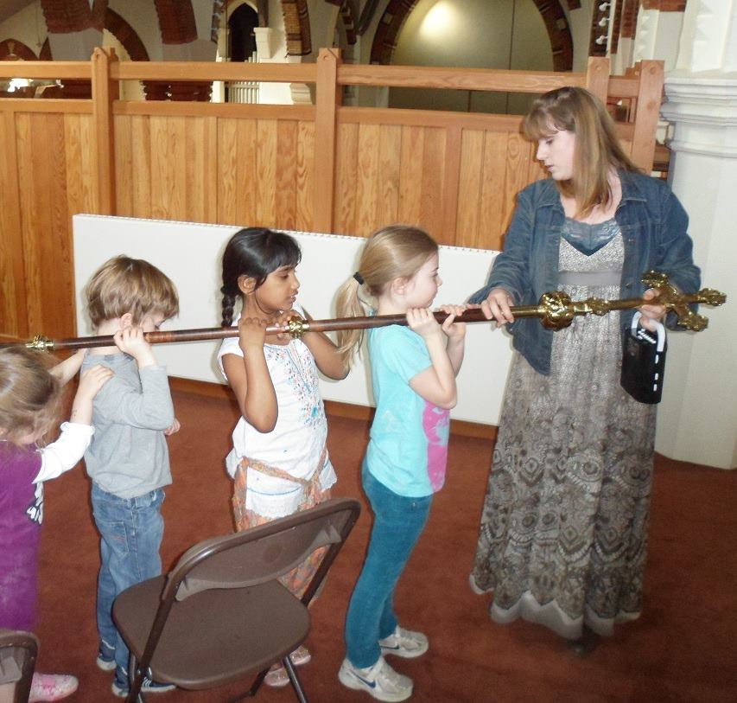
(Lead children to the place where you can all gather in the dark – ideally, this should be as close to pitch black as possible and provide a visible approach – the bottom of a tower stairwell is perfect, but work with what you’ve got. It might help to sing as you move, or carry a cross over the shoulders of several of the children, to provide a focus. We usually sing “Were you there when they crucified my Lord?”. Get the children into the dark place – there will probably be some giggling and fidgeting. Wait until they’re settled. You can talk as you go, about how dark and cold it is, how we’re in the tomb with Jesus, waiting to see what happens next. The following is an excerpt from the Easter Sermon of St. Euthemius the Great. Begin when everyone is settled in the dark. Either memorise it or pre-record it, or have a very small light source available.)

Something strange is happening. There is a great silence on Earth today. The whole Earth is silent, because the King of Heaven and Earth is dead. God has died, and Hell trembles with fear.

Jesus has gone to the place of the dead, to search for Adam and Eve and all who have gone down to darkness and the shadow of death. Jesus approaches them, bearing the cross, the weapon that has won him the victory. He takes them by the hand, and raises them up, and this is what he says:

(from now on, your voice should gradually rise in excitement, while still remaining solemn. The volunteer playing Jesus appears, candle lit, into the darkness, and brings you out, so that you all enter the celebration space at the end of the reading. You can also play the finale of Godspell, from the start of “Long Live God” against the rest of this speech – the transition from the quiet of “Long Live God” to the joy of “Prepare ye the way of the Lord!” works well.)

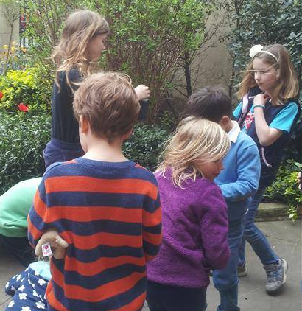
“Awake, sleepers, and rise from the dead, and Christ will give you life. Rise from the dead, for I am the light of the dead. Out of love for you, I, your God, became a human being and came to earth. For your sake, I died today upon earth. You once reached out to take fruit from a tree, and to save you, I have been nailed to a tree. You were driven out of Paradise, and I have come to lead you to Heaven. I did not create you to be held prisoner forever.

“Rise up! Let us leave this place! For I have died with you, and you shall rise with me! The Kingdom of Heaven has been prepared for you from all eternity!”

(Enter the celebration space! Let the children run around for a bit if they want to and release the story’s tension. Plant flowers or have cake or something to celebrate.)

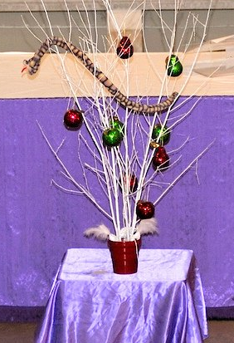
TREE OF LIFE

So we have this tree, which is used for our Christmas pageant. It’s simply a few spray-painted branches stuck in some sand. It cost less than £20 to make, and we’ve used it for 7 years.

Our pageant is a dramatized Lessons and Carols service (People, Look East, from Gretchen Wolff Pritchard’s book, Go Tell It On The Mountain, available from the-Sunday-paper.com and Amazon). So the tree starts out as the tree of knowledge, then becomes the family tree of Jesse and the tree of life, with a small subtle nod at being a Christmas tree on the way.

We decided to expand this through Lent and Holy Week.

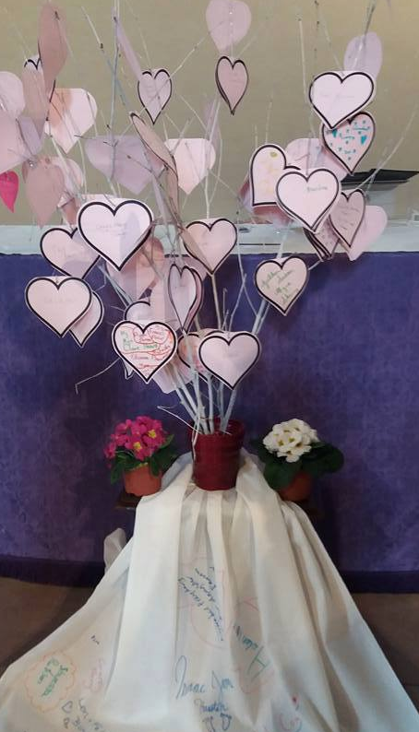

On Mothering Sunday, our congregation writes the names of anybody who has played a mother’s role in their lives. These names are placed in the offertory plates, placed on the tree (out of sight, during the Eucharistic Prayer), and then the tree – and those whose names are on it – are blessed. (Those who can’t write can draw.)

Recently, we added a prayer station on the way back from communion, for people to write or draw names of children we have mothered who have died, or mother figures who have died, on a piece of fabric. This now goes with the tree.

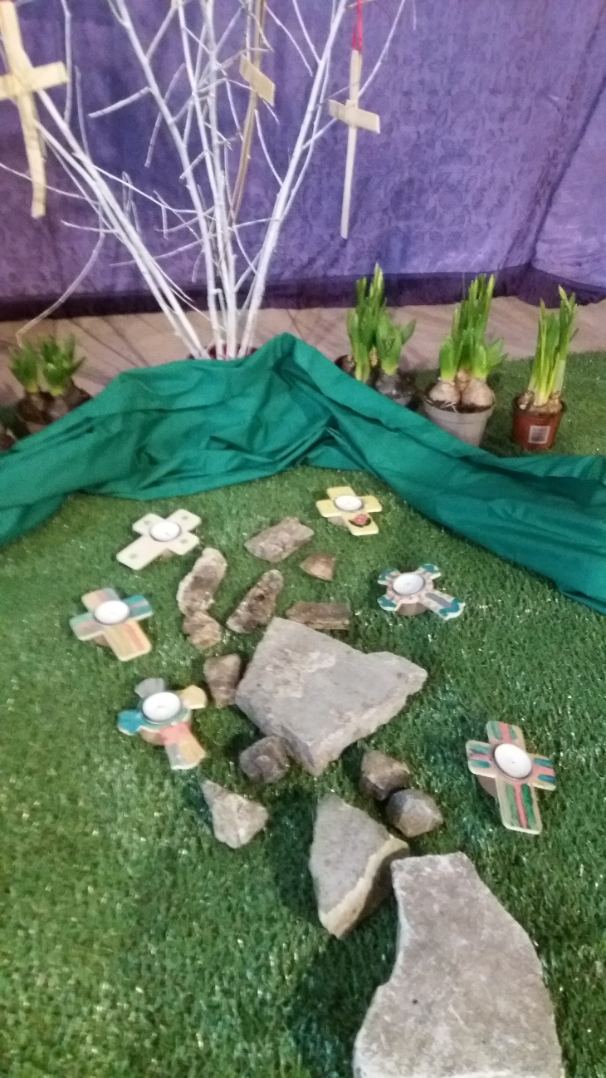
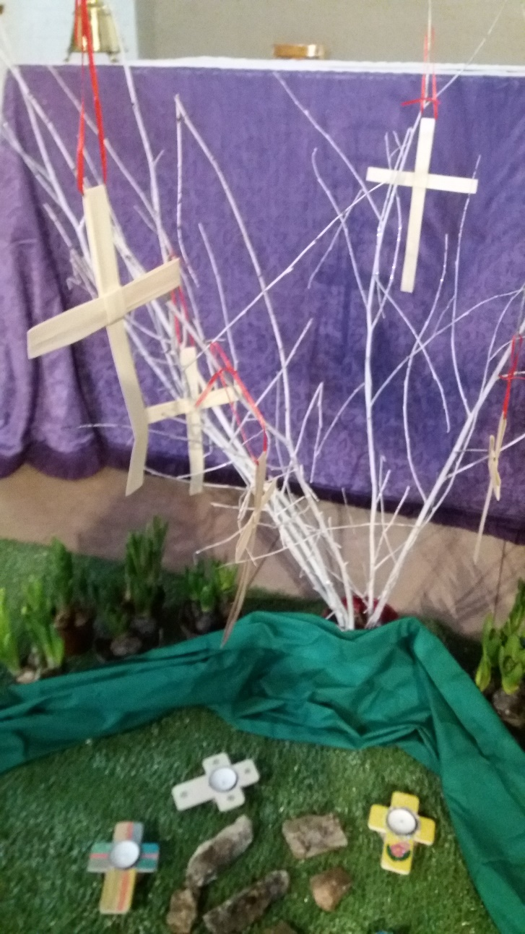
On Palm Sunday, our Easter Garden goes up. The tree is present, with palm crosses.

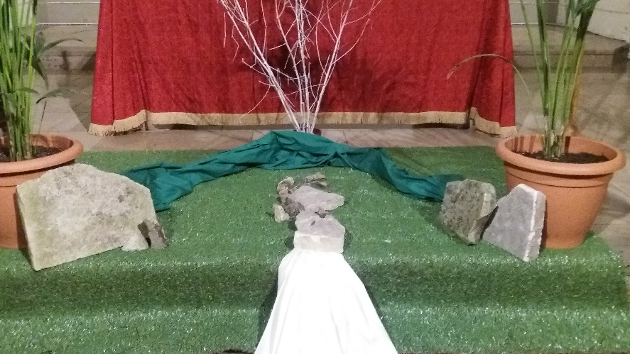
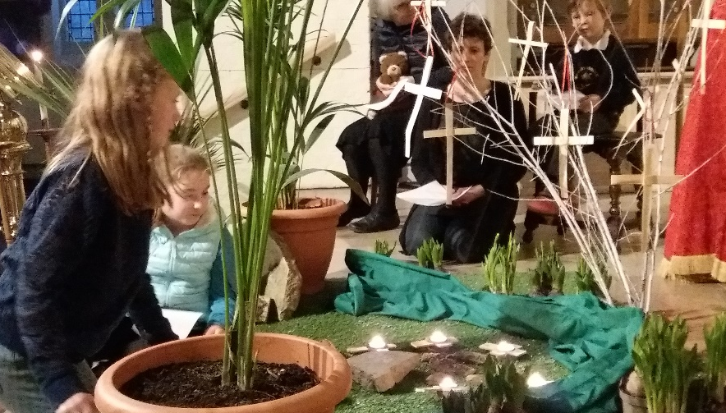
During our All-Age Service on Maundy Thursday, we strip the altar, including the tree.

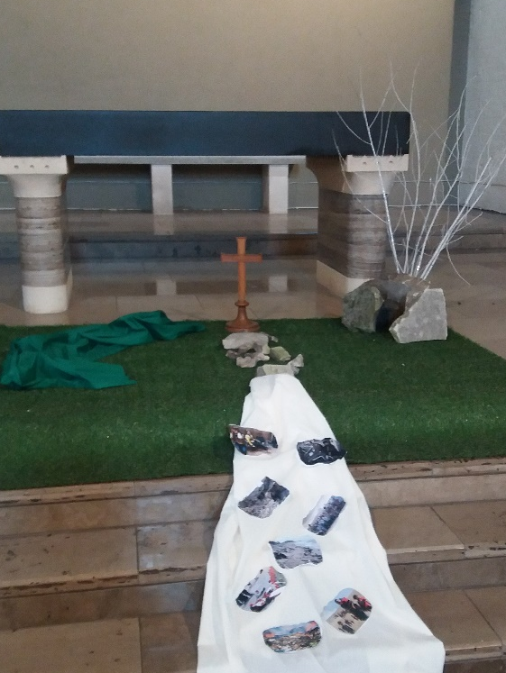
On Good Friday, the tree symbolically connects with the cross, as the Easter Garden is transformed into Golgotha.

On the white cloth are pictures of recent news – war, violence, etc.

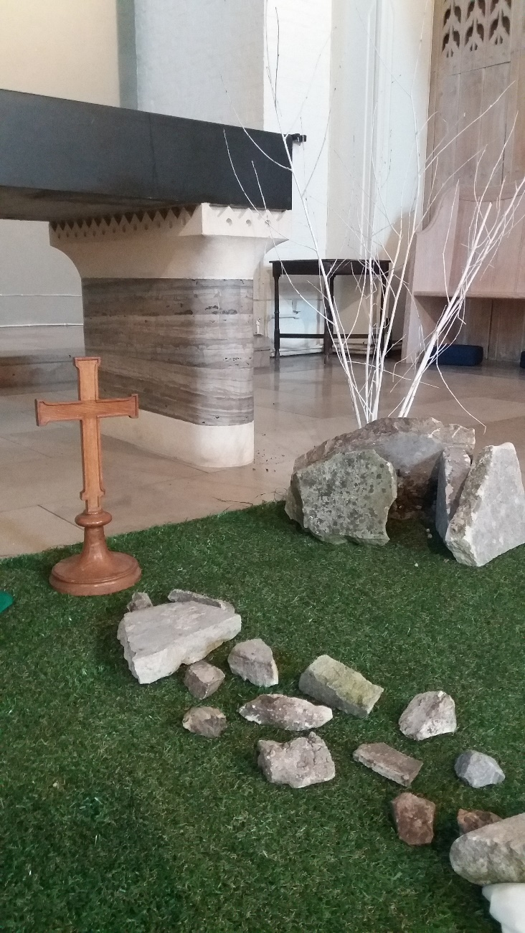
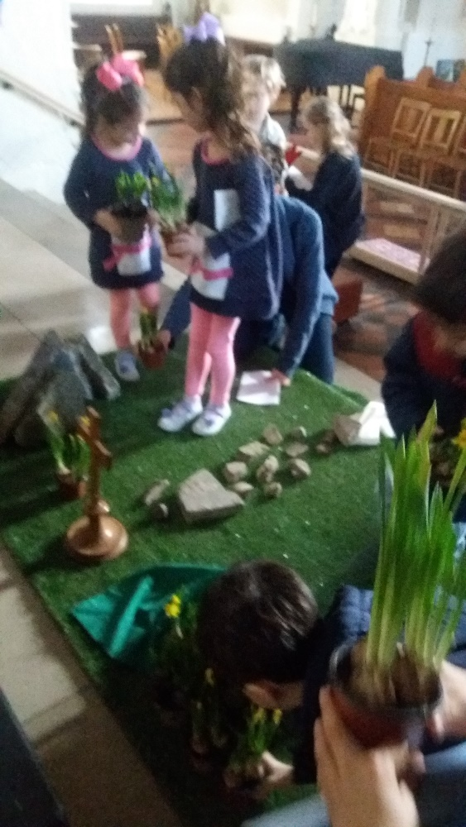
During the Children’s Stations of the Cross, flowers – and a Jesus doll bound in white cloth – are brought into the Easter Garden. The Jesus doll is placed in the tomb, and a stone is rolled across it.

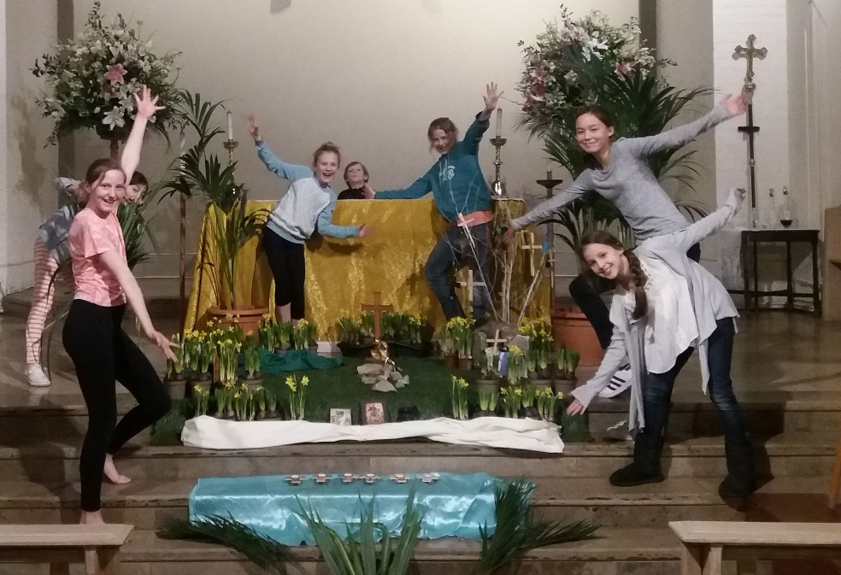
Before the Easter Vigil, the tree is transformed one more time. We had a Youth Group sleepover the night of the Vigil, so they did the work of changing the garden. The tree is now hung with items the Sunday School makes specifically for that during Holy Week events, as well as the palm crosses again. (Scratch art crosses from Baker Ross – we also had paper flowers one year.)
