What Happens at Church
Younger children

We come together. | 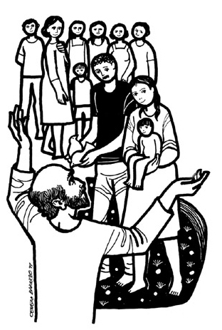
We read from the Bible. | 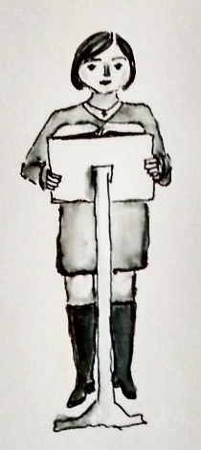
We think or talk about what we’ve heard. | 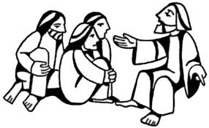
We pray. | 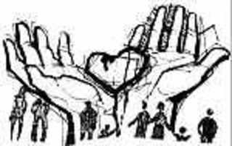
We say “peace.” | 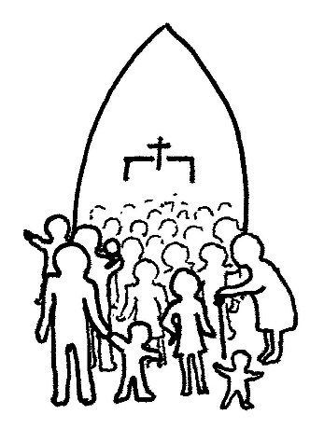
We share. | 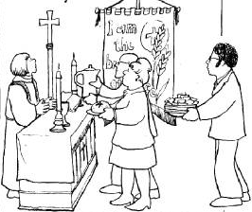
We have bread and wine or a special blessing. | 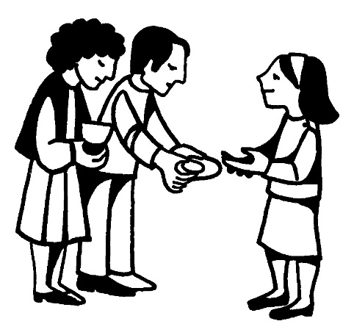
We say thank you to God. | 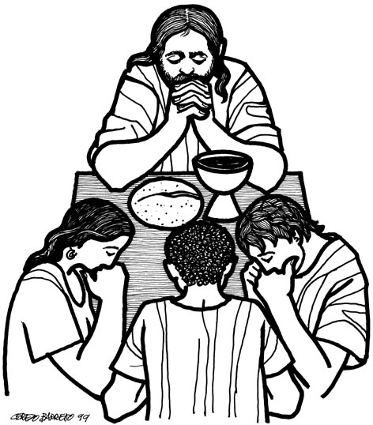
We go out. | 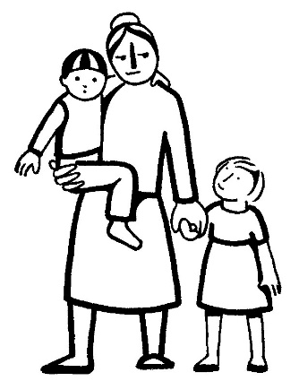
Artwork: Revd. Ally Barrett, Gretchen Wolff Pritchard, Gertrud Mueller Nelson, Cerezo Barredo

