What Happens at Church
Older children and adults
Usually we STAND to sing, SIT to listen, and KNEEL to pray. You may join these actions if you want to, and if you are able, but you don’t have to. There is one reading we usually stand for – the one about Jesus’s life, called the GOSPEL.

We gather in God’s name.  We say a prayer asking God to forgive what we’ve done wrong and help us to want and do good things. | 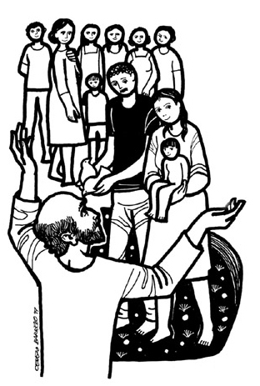
We read from the Bible.  There are usually three readings, and a sung poem called a Psalm. | 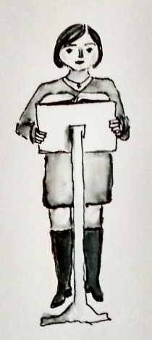
We think or talk about what we’ve heard. Someone may give a talk called a sermon. | 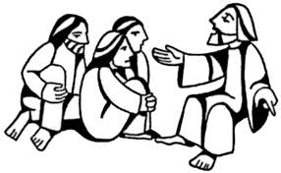
We pray. Often, we kneel to pray. You may want to fold your hands together or hold your hands up. | 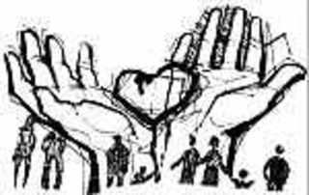
We share “peace” by shaking hands. | 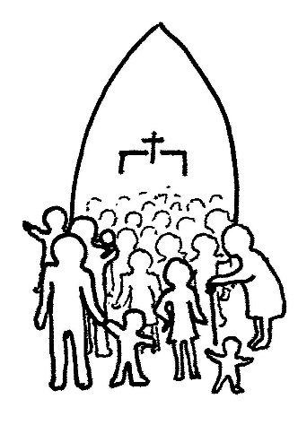
If we can, we give some money to help the church do its work. It doesn’t matter how much or how little you give.  Bread and wine are brought to the table. | 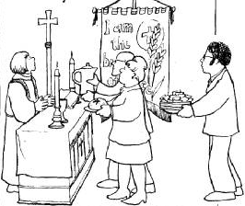
We have bread and wine. This is a sign of Jesus’s body and blood. Jesus is with us here.  If you aren’t yet ready for the bread and wine, you can still get a blessing. | 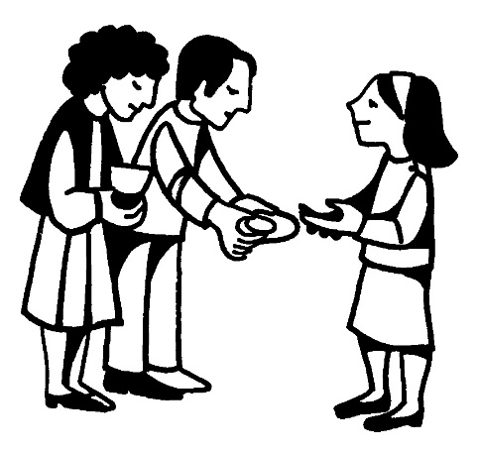
There may be a place to light a candle after you have bread and wine. You don’t have to do this, but some people find it helps them pray.  We say thank you to God. | 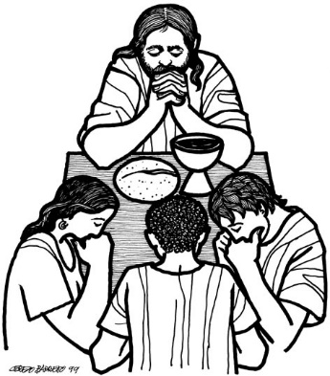
We go out. There may be tea or coffee to share together after the service. Ask the vicar if you’re not sure where to go.  Artwork: Revd. Ally Barrett, Gretchen Wolff Pritchard, Gertrud Mueller Nelson, Cerezo Barredo | 